SMBCLIENT & SMBMAP – COMPREHENSIVE TECHNICAL DOCUMENTATION
SMB Enumeration and Access Tools for Ethical Hacking & Penetration Testing
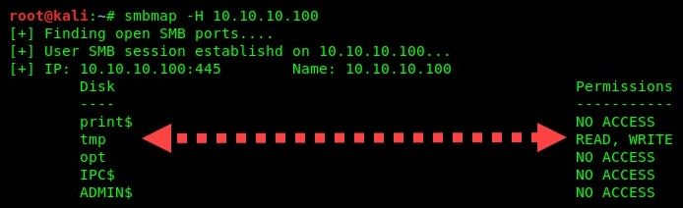
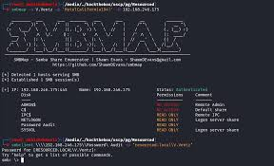
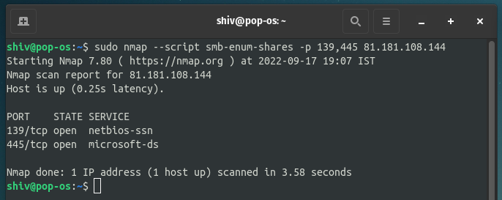
4

ABSTRACT
Server Message Block (SMB) is a core protocol used in Windows environments for file sharing, authentication, and inter-system communication. Due to frequent misconfigurations, SMB services often leak sensitive information or allow unauthorized access. This document presents a comprehensive technical study of SMBCLIENT and SMBMAP, two widely used tools for enumerating and interacting with SMB services. The report explains the theoretical background, working mechanisms, command usage, practical case studies, advantages, limitations, and defensive considerations. The objective is to provide an academic and practical understanding suitable for cybersecurity coursework, lab records, interviews, and professional penetration testing engagements.

PART A: SMBCLIENT TOOL
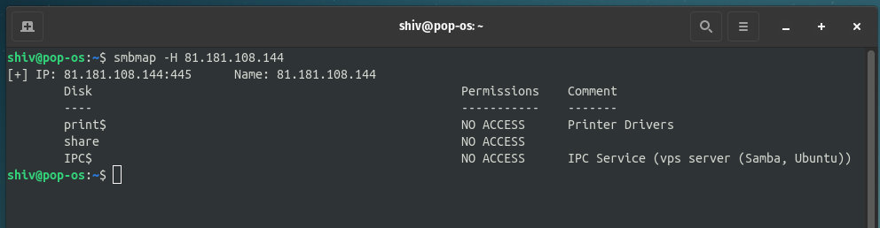
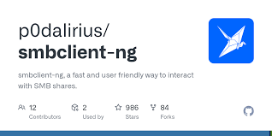


1. INTRODUCTION TO SMBCLIENT
SMBCLIENT is a command-line utility that allows Linux systems to interact with Windows SMB shares. It functions similarly to an FTP client but is designed specifically for SMB/CIFS services.
In penetration testing, SMBCLIENT is used after enumeration to:
- Access shared folders
- Download or upload files
- Verify read/write permissions
- Manually explore SMB resources
Unlike automated tools, SMBCLIENT provides direct, interactive access to SMB shares.

2. OBJECTIVE OF USING SMBCLIENT
The primary objectives of SMBCLIENT are:
- To list available SMB shares
- To access SMB shares interactively
- To read, download, or upload files
- To validate permissions discovered during enumeration
SMBCLIENT is typically used in the Enumeration → Access Validation phase.

3. WORKING MECHANISM OF SMBCLIENT
SMBCLIENT communicates directly with the SMB service over TCP ports 139 or 445. It authenticates using:
- Anonymous (null session) access
- Valid username and password
- Domain credentials (in AD environments)
Once connected, it provides an interactive shell to navigate and interact with the share.

4. INSTALLATION AND ENVIRONMENT
SMBCLIENT is pre-installed in Kali Linux.
To verify installation:
smbclient --help
It does not require root privileges for basic usage.

5. COMMAND USAGE AND ANALYSIS (SMBCLIENT)
5.1 List SMB Shares (Anonymous)
smbclient -L //192.168.1.10 -N
Lists available shares without authentication.

5.2 List SMB Shares (Authenticated)
smbclient -L //192.168.1.10 -U user

5.3 Connect to a Share
smbclient //192.168.1.10/shared -U user

5.4 Common SMBCLIENT Commands
ls # list files
cd dir # change directory
get file # download file
put file # upload file

6. PRACTICAL CASE STUDY (SMBCLIENT)
Scenario
A penetration tester identifies a readable SMB share during enumeration.
Execution
smbclient //192.168.146.128/public -N
Observations
- Accessed share without authentication
- Downloaded configuration files
- Identified sensitive credentials
Impact
Manual access via SMBCLIENT confirmed misconfigured share permissions and enabled data exfiltration testing.

7. ADVANTAGES & LIMITATIONS (SMBCLIENT)
Advantages
- Direct interaction with SMB shares
- Supports upload and download
- Works with anonymous access
Limitations
- Manual and time-consuming
- No automated permission mapping
- Requires prior enumeration

PART B: SMBMAP TOOL
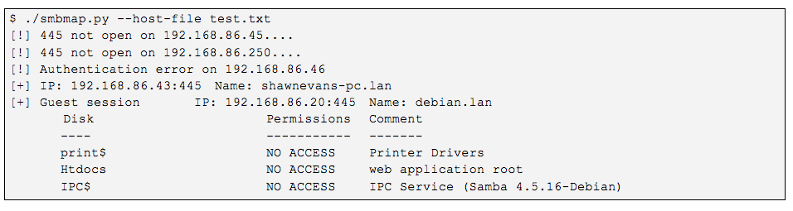
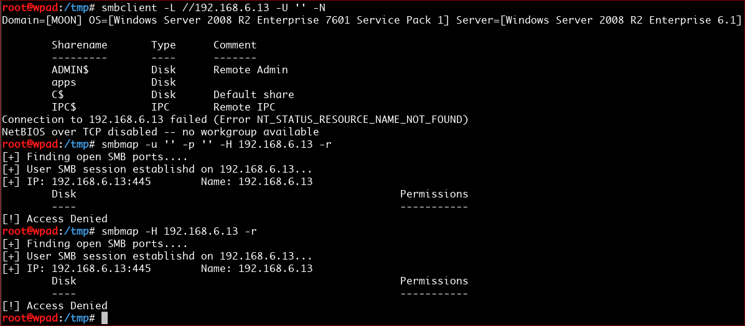
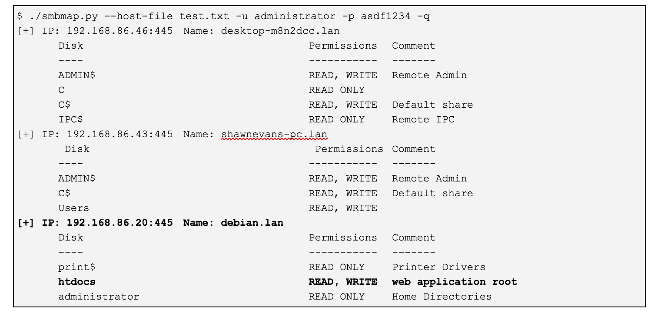

8. INTRODUCTION TO SMBMAP
SMBMAP is an automated SMB enumeration tool designed to map SMB shares and their permissions across a target system or network. It provides a clear overview of which shares are readable or writable.
SMBMAP is often used before SMBCLIENT to decide which shares are worth accessing.

9. OBJECTIVE OF USING SMBMAP
The objectives of SMBMAP are:
- To enumerate SMB shares automatically
- To identify read/write permissions
- To discover sensitive files
- To streamline SMB enumeration
SMBMAP fits squarely in the Enumeration phase.

10. WORKING MECHANISM OF SMBMAP
SMBMAP authenticates to the target SMB service (anonymously or with credentials) and queries available shares. It then attempts controlled access to determine permission levels.
Results are presented in a concise, readable format.

11. INSTALLATION AND ENVIRONMENT
SMBMAP is pre-installed in Kali Linux.
To verify installation:
smbmap --help

12. COMMAND USAGE AND ANALYSIS (SMBMAP)
12.1 Anonymous Enumeration
smbmap -H 192.168.1.10

12.2 Authenticated Enumeration
smbmap -H 192.168.1.10 -u user -p password

12.3 Enumerate with Domain
smbmap -H 192.168.1.10 -u user -p password -d DOMAIN

12.4 Download Files Automatically
smbmap -H 192.168.1.10 -u user -p password -R

12.5 Search for Sensitive Files
smbmap -H 192.168.1.10 -u user -p password -r --grep password

13. PRACTICAL CASE STUDY (SMBMAP)
Scenario
A penetration tester scans a Windows server for SMB misconfigurations.
Execution
smbmap -H 192.168.146.128
Observations
- Identified readable public share
- Discovered writable uploads directory
- Located sensitive documents
Impact
SMBMAP enabled rapid identification of high-risk shares, accelerating the testing workflow.

14. ADVANTAGES & LIMITATIONS (SMBMAP)
Advantages
- Automated permission mapping
- Clean and readable output
- Faster than manual enumeration
- Ideal for internal pentests
Limitations
- No interactive shell
- Depends on SMB configuration
- Less control than smbclient

15. SMBCLIENT VS SMBMAP
Tool | Purpose | Best Use Case
SMBCLIENT | Manual SMB access | File interaction
SMBMAP | Automated enumeration | Permission mapping
Enum4linux-ng | Broad SMB enum | User/share discovery
SMBMAP identifies what to access, SMBCLIENT performs the access.

16. SECURITY AND DEFENSIVE CONSIDERATIONS
Organizations can mitigate SMBCLIENT/SMBMAP abuse by:
- Disabling anonymous SMB access
- Restricting share permissions
- Enforcing SMB signing
- Monitoring SMB enumeration activity

17. LEGAL AND ETHICAL CONSIDERATIONS
Both tools must be used only with explicit authorization. Unauthorized SMB access or enumeration can result in serious legal consequences.

18. CONCLUSION
SMBCLIENT and SMBMAP are essential tools for Windows and SMB-based penetration testing. While SMBMAP provides a rapid overview of share permissions, SMBCLIENT enables direct interaction and validation. Mastery of both tools is crucial for effective SMB enumeration, access verification, and post-enumeration exploitation planning.

19. REFERENCES
- Kali Linux Documentation
- Microsoft SMB Protocol Documentation
- OWASP Windows Security Testing Guide

